Indigo Promotions Limited


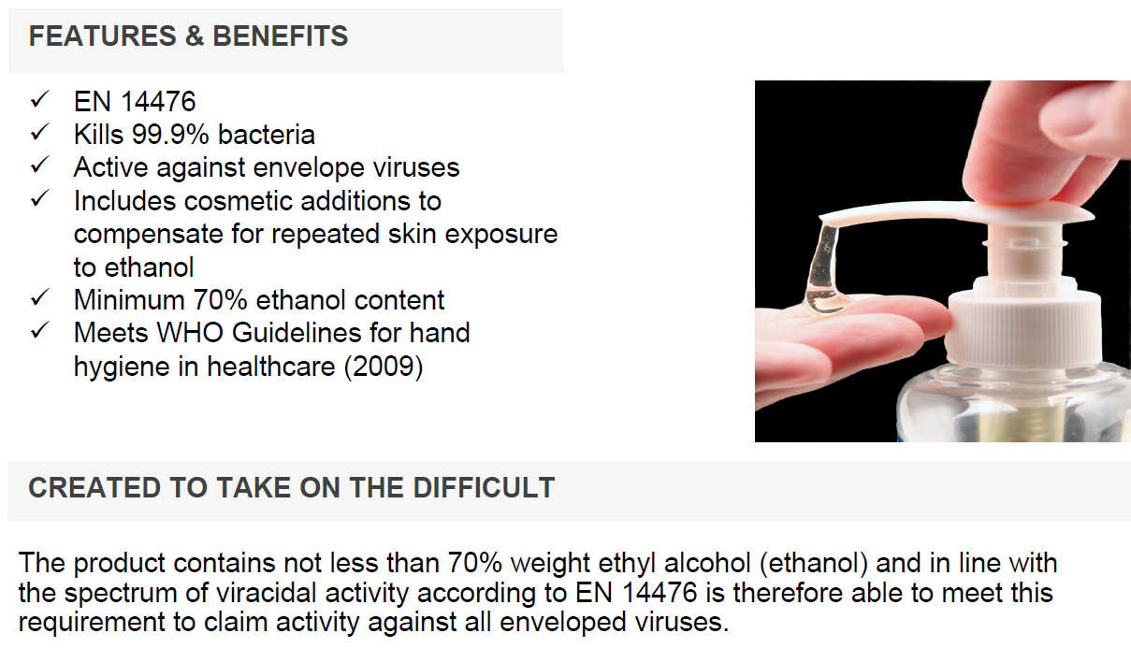

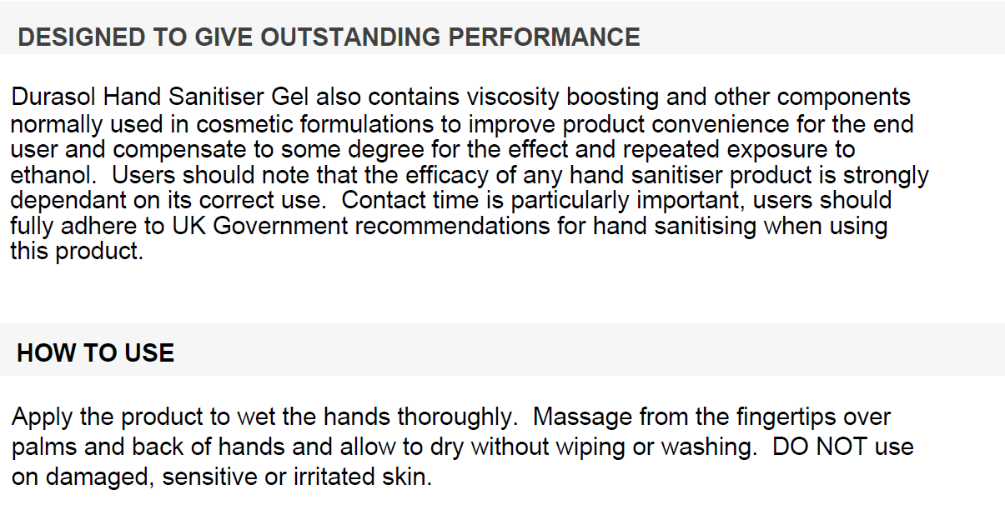
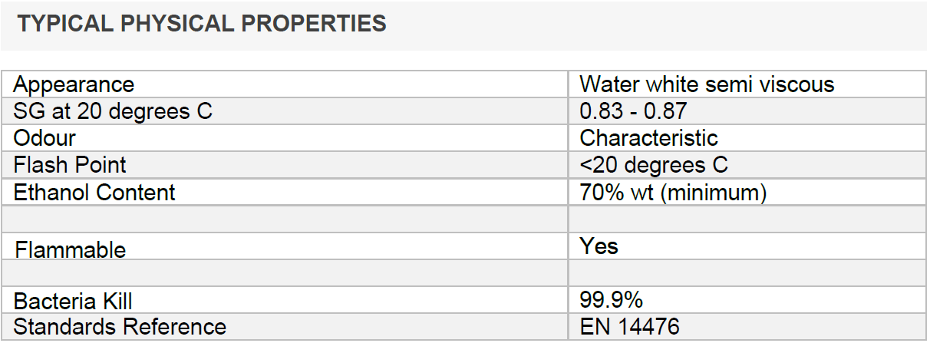
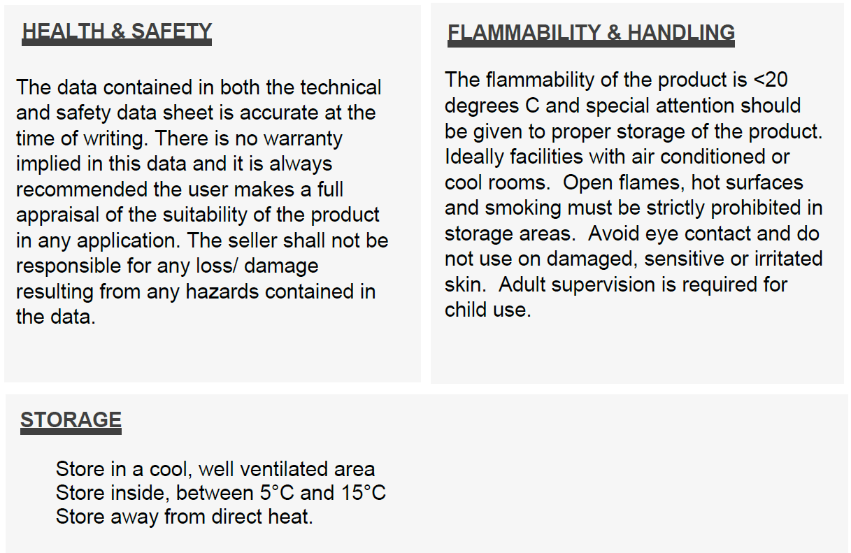


Indigo Promotions Limited
21A Meridian House, Road One Winsford Industrial Estate
Winsford, Cheshire, CW7 4QG,
Tel: 01606 871555
e. sales@indigo-promotions.co.uk www.indigo-promotions.co.uk
Company Registration number: 04992437

